Jenkins Task
Task Description:

Launch jenkins and explore creating projects and users.

- Created a new EC2 instance in the AWS console.
- Connected to instance with SSH from the PowerShell. And also update the system
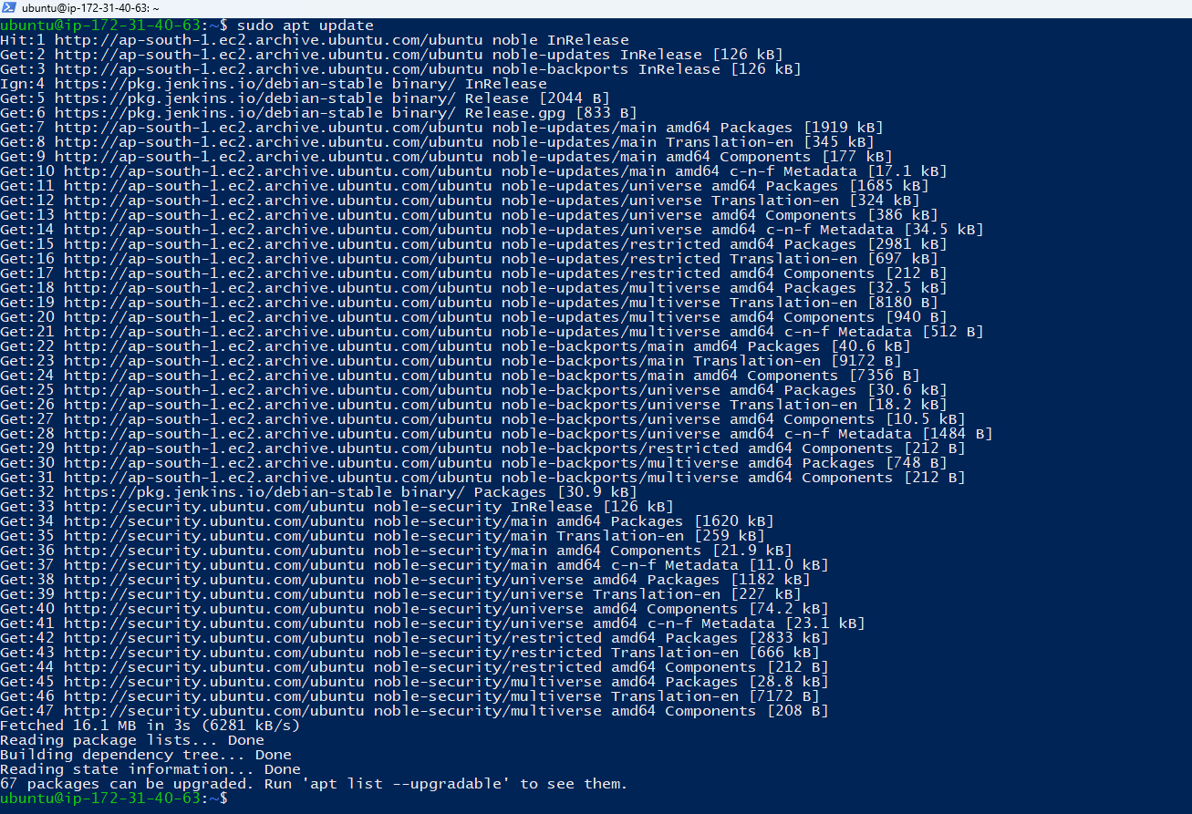
- Installed the latest version of Jdk.
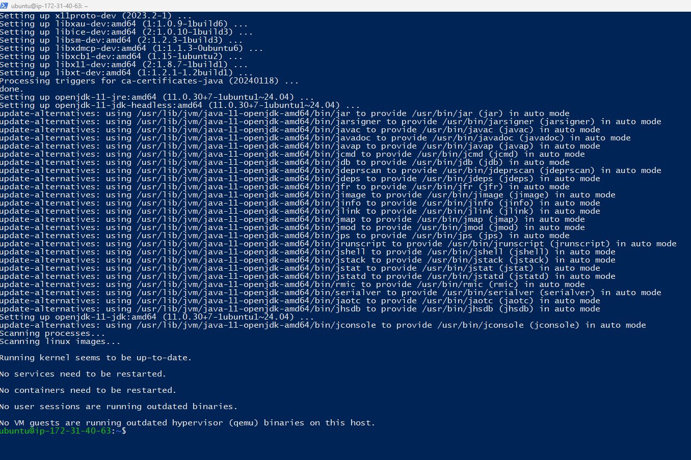

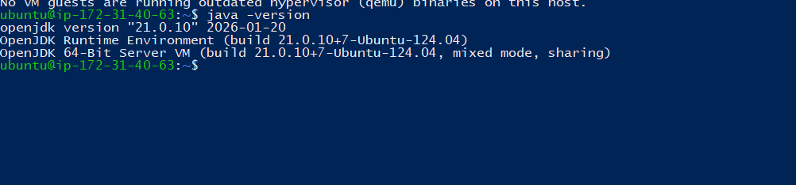
- Jenkins is installed and the service is Up and running
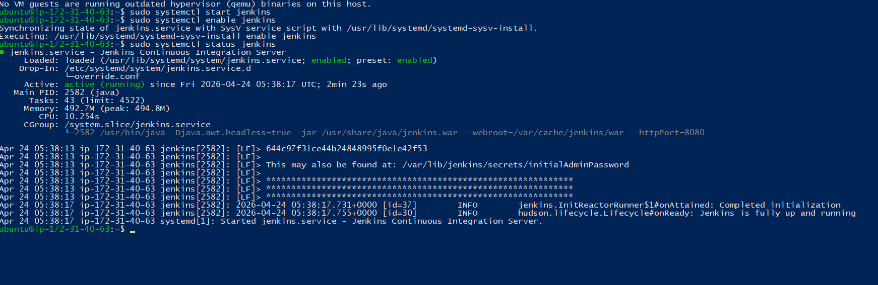
- Got the admin password for the Jenkins to login in the browser
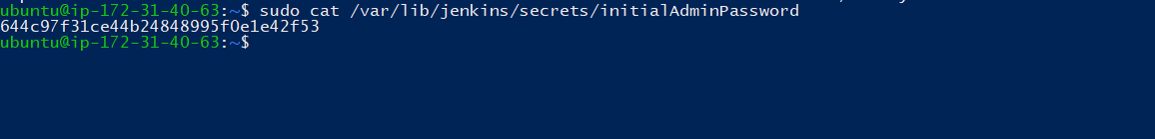
Installed suggested plugin
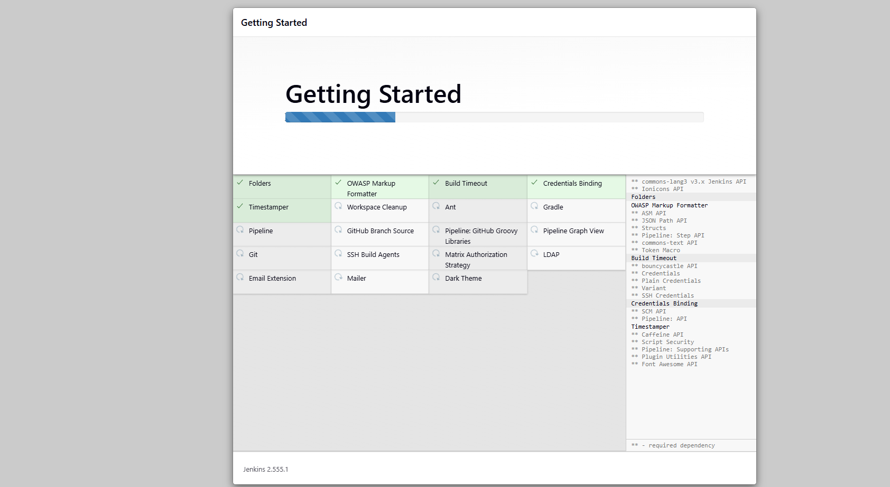
- Configured the Jenkins and logged in with user name and password created .
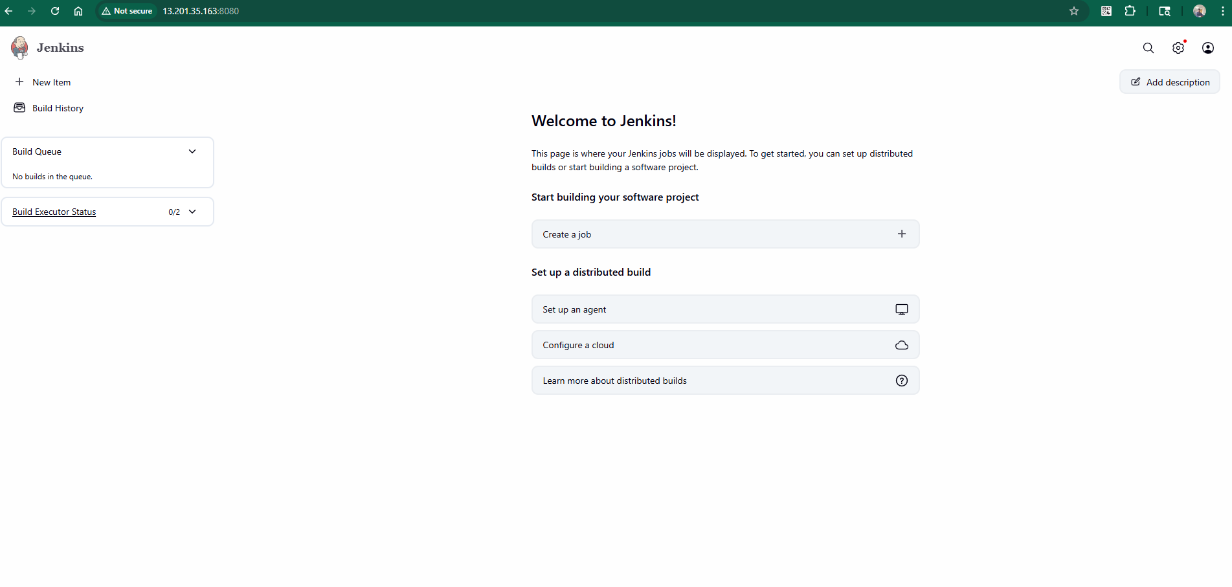
- Created a new build with shell and added the details and did a build run
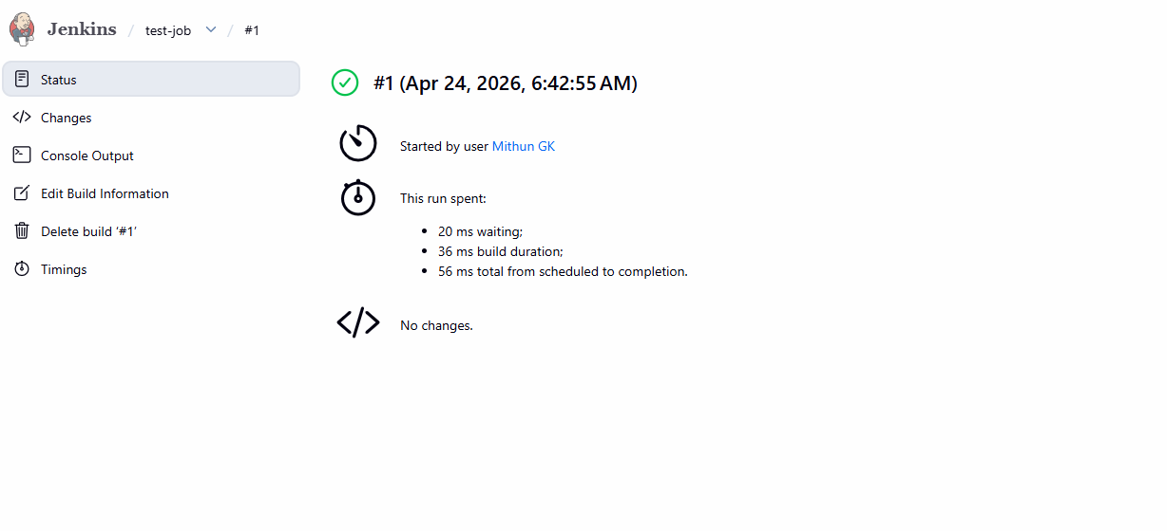
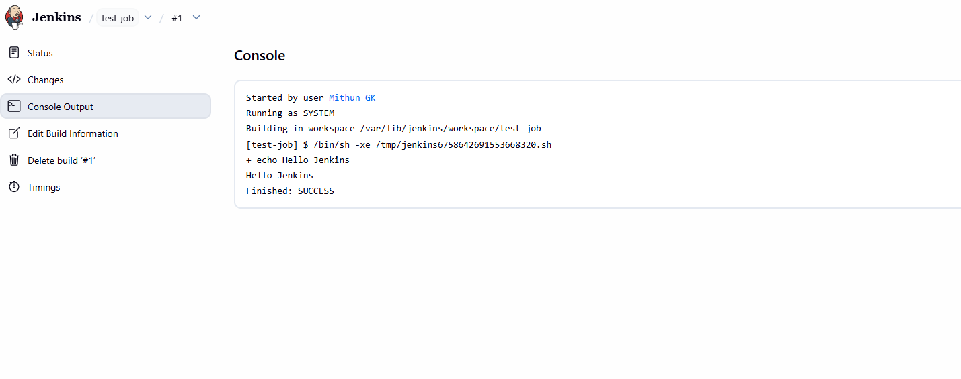
- Made the changes and re- run the Build and have the new output
